CVC 30th Anniversary Celebration
Leaders Guide

30 Years of Building Tomorrow’s Leaders
Historic Endview November 4 - 6, 2022

Come celebrate the 30th Anniversary of the Colonial Virginia Council with a weekend of camping, fun, scout shows, and competitions

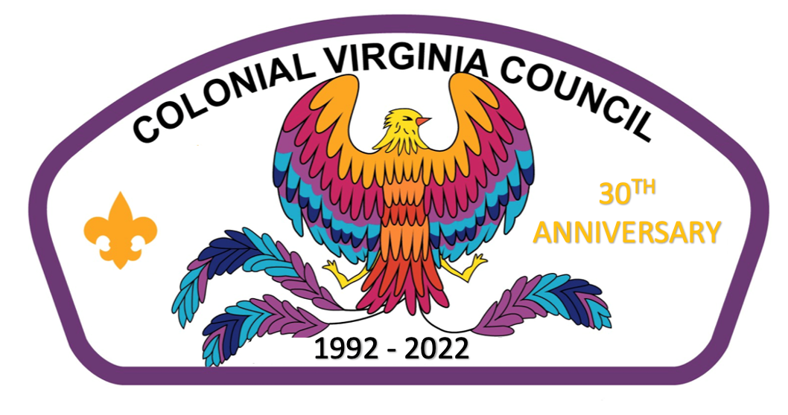
CVC 30th Anniversary Celebration
30 Years of Building Tomorrow’s Leaders
A time for Scouts and Scouters of all ages and the Public to come together and celebrate scouting and the 30th Anniversary of the Colonial Virginia Council.
Scouts and Scouters from the Colonial Virginia Council will gather November 4 – 6, 2022, at Historic Endview for a weekend of camping with a celebration being held Saturday November 5 from 10am until 4pm. Expect loads of fun! Activities include Scout Shows, gaga ball, fan favorite Lumberjack and Highland Game activities, archery and sling shot shooting, COPE Games, a climbing wall, and handicraft activities to name a few. Scouters and Adults will not be left out either as there will be dutch oven cooking, and a Pinewood Derby, just for adults. There will also be EXPO exhibitors, food trucks, and everyone who registers for the weekend gets a CVC 30th Anniversary Celebration patch!
Leaders, please use this guide to prepare for the CVC 30th Anniversary Celebration. This guide provides general and specific information for a safe, fun event for your unit. Please remember to share this information with other adult leaders and the SPL.
The fee for the weekend (camping) is $20.00 per youth and adult. ($5 late fee will apply for anyone registering after October 15th). Last day for online registration is October 29th at 11:59pm. Each unit must have health forms for all its campers in camp at all times. If there are special health requirements for any youth or adult, please notify the event chairman. Troops, Crews, and Ships are to supply their own meals and gear.
Don’t want to camp for the weekend but want to attend the fun on Saturday? Then do so! Admission for Saturday is $10 for the first scout/per family, $5 for the second scout/family, with a cap at $15/family. Saturday only admission for adult scouters is $10. No pre-registration is required, but if you want to be guaranteed a patch, you will need to pre-register. Non-scouting friends and family can attend for free, so ask them to attend and join the celebration.
Saturday night we will have a show celebrating 30 years of scouting in the Colonial Virginia Council along with traditional Saturday night activities – a campfire with skits, songs, cheers, and Scout antics. Each unit is encouraged to show off their enthusiasm and talents by entertaining us at the campfire. Please sign up for your skit, cheer, and/or song by 5:00 p.m. with the Campfire MC at the Staff area.
Please forward any questions or concerns to the event chairman, Mike O’Flynn at 757-837-2984 or mikeoflynn1@yahoo.com prior to the event.
We look forward to seeing you at Endview!
CVC 30th Anniversary
What is it?
A time for Scouts and Scouters of all ages, and the Public to come together and celebrate scouting and the 30th Anniversary of the Colonial Virginia Council. An opportunity for Cub Scouts, Scouts BSA, Venturing, and Sea Scouts to demonstrate to parents, friends, other scouting areas, and the public the fun and exciting activities scouts do year-round and what a great training ground scouting is for the youth of America. Scouting units will stage “live demonstrations” using Scout Shows of the many skills, activities, advancement, and achievement requirements of the Scouting Program.

When is it?
November 4 - 6, 2022 The weather should be awesome. However, everyone should be ready to participate rain or shine. If severe weather is expected or hits during the event, the event may be cancelled or postponed.

Where is it?
Historic Endview (formerly known as Endview Plantation), 362 Yorktown Rd Newport News, VA. 23603. This will be jamboree style camping. Campsites will be in a large field. There will be port-a-johns and potable water but that’s about it. No electricity, so plan accordingly.

Who can attend?
Weekend Camping is open to all Scouts BSA Troops, Venturing Crews and Sea Scout Ships in the Colonial Virginia Council along with Cub Scout Packs! If a pack doesn’t want to camp but Webelos do, find a Scouts BSA Troop to sponsor the Webelos.
Still want to attend the celebration on Saturday but don’t want to camp for the weekend, no problem. We have a day pass for you. Attend the events Saturday 10am to 4pm. You can even attend the Saturday night celebration show. (As long as you are in scouting).

What am I missing?
There will be Lumberjack & Highland Games activities, EXPO exhibitors with demonstrations, education, and additional activities. A fire truck, ambulance, Police K-9 Unit, and food trucks just to name a few. There will be displays depicting the History of the CVC, booths from each area of scouting – Cub Scouts, Scouts BSA, Order of the Arrow, Venturing, and Sea Scouts and Scout Shows. Adult Scouters will not be left out as they can participate in a Pinewood Derby and Dutch Oven Cooking.

What is a Scout Show?
A Scout Show is a celebration of what Scouting Units do. It is an opportunity for cub scouts, scouts, venturing, and sea scouts to demonstrate to parents, friends, other scouting areas, and the public the fun and exciting activities scouts do year-round and what a great training ground scouting is for the youth of America. Basically, scouting units stage “live demonstrations” of the many skills, activities, advancement, and achievement requirements of the Scouting Program
The purpose is to gain support in the community for the Scouting Program and for the individual unit. Cub Scout Packs can use the Scout Show to reach boys, girls, and their parents who are curious about Scouting but may not have attended School Night or who want more information. Scouts BSA, Venturing, and Sea Scouts can use the Scout Show to reach scouts in the younger programs and give them a taste of their program and reach older scouts and youth not associated with Scouting. The Scout Show also is an opportunity to show the public what scouting is and how it helps the build better citizens and leaders. This can go a long way in getting support for things like Popcorn/Peanut Sales, Friends of Scouting, and other community service projects. Lastly and just as important, it gives the Scouts and their leaders a chance to show off their skills. In short, The Scout Show is something for everyone.

Cost?
The camping fee for the weekend $20.00 per youth and adult if paid by October 15th. Cost goes up to $25 per youth and adult if paid after October 15th. The last day of registration is October 29th @ 11:59pm. Each unit must have health forms for all campers, in camp, at all times. If there are special health requirements for any youth, or adult, please contact Mike O’Flynn at mikeoflynn1@yahoo.com. Everyone must provide their own gear and food.
Saturday Only Attendance fee is $10 for the first scout/scouting family, $5 for the second, with a cap at $15 per scouting family. Adults coming with the scouts get in free.
Saturday Only Attendance for Adult Scouters is $10.
No fee for the public.

Difference between this weekend and a Highland Games or Lumberjack Weekend?
We will need everyone’s help breaking down the main field and parking areas Saturday Night, ending in a police line in the Main Field and Parking Area for Leave No Trace. We need to be good environmental stewards to Historic Endview and return used areas to their original condition. Please plan accordingly.

At night, in addition to the CVC 30th Anniversary Celebration Show, there will be a campfire full of songs, skits, jokes, tall tales and lots of fun. Units or individuals are encouraged to perform a song, skit, jokes, etc. at the evening campfire.

Expected Cub Activities
- Leather Work
- Archery
- Sling Slots
- Claymore Hack
- Obstacle Course
- Welly Course
- Parachute
- Caber Toss
- Gaga Ball Pit
- Various Crafts – talking feathers, catapults, crossbow kits

Expected Scout Activities
- Leather Work
- Archery
- Tomahawk Throw
- Knife Throw
- Weight Over Bar
- Caber Toss
- Weight Throw
- Stone Put
- Two Man Saw
- Obstacle Course
- Gaga Ball Pit

*Activities are subject to change

CVC 30th Anniversary Celebration Schedule

Friday, November 4
9:00 a.m. – 9:00 p.m. Setup Main Field & Parking Area
5:00 p.m. -- 9:00 p.m. Check-in at Registration Area and set up campsites
5:00 p.m. – 9:00 p.m. Set up for Scout Shows and Scouting Areas
8:15 p.m. – 8:45 p.m. Leaders Meeting at HQ
10:00 p.m. Taps – Lights Out

Saturday, November 5
7:00 a.m. Reveille
7:00 a.m. - 8:30 a.m. Breakfast in campsite
7:00 a.m. – 09:45 a.m. Continue setting up main field
9:45 a.m. - 9:55 a.m. Opening Ceremony
10:00 a.m. - 4:00 p.m. Celebration Activities in Main Field
Lunch/Time determined by each troop
12:00 p.m. – 1:00 p.m. James E. West Endowment Luncheon (Invitation Only)
5:00 p.m. - 7:30 p.m. Dinner in campsite
5:00 p.m. – 10:00 p.m. Breakdown Main Field & Parking Area
5:45 p.m. Retire Colors (Optional-Staff will conduct)
8:00 p.m. - 9:30 p.m. 30th Anniversary Celebration Show, Campfire
10:00 p.m. Taps – Lights Out

Sunday, November 6
7:00 a.m. - 8:30 a.m. Breakfast and Clean-up
9:00 a.m. - 9:30 a.m. Chapel Service
9:30 a.m. – 10:00am Check-out

Be sure to check Lost and Found prior to departure

Rules and Regulations
The following rules were made to ensure a fun and safe camping experience. It is the responsibility of the adults in charge to see that their Scouts and Scouters know and understand these rules. Anyone caught violating them may be asked to leave the camp.

CHECK-IN/REGISTRATION
Troops, Crews, Ships and Packs may arrive at 5pm on Friday, November 4 to set up campsites. If you plan to arrive before 5pm you MUST contact Event Chair Mike O’Flynn to make arrangements (or you may end up waiting until our staff is ready to receive you). Upon entering camp, proceed to the registration area to sign in (located at HQ Tent). You will receive your campsite assignment number at that time.
THE ONLY VEHICLE ALLOWED INTO THE CAMPSITE IS THE VEHICLE USED TO HAUL THE TROOP TRAILER AND GEAR. IF A UNIT HAS MORE THAN ONE VEHICLE ONLY ONE WILL BE ALLOWED IN AT A TIME!!!! PLEASE FOLLOW THESE INTRUCTIONS!! No vehicles are allowed to stay in the campsite areas or activity field.
All Vehicles must be in the parking area by 9:00 Friday night!!!!!
HANDICAPPED PARKING
Requests for special parking passes for medical conditions will be made on a case-by-case basis. Special passes must be requested in advance and will be issued on the day of the event. We prefer to discuss the request prior to event to allow for the greatest degree of accommodation. Every reasonable effort will be made to accommodate those with physical disabilities or special needs.

REGISTRATION & FEES
There is a registration/attendance fee for Scouts and Scouters, including those only attending Saturday, to cover patches, ribbons, toilets, insurance and park fees. All camping participants must be listed on the registration form and turned into the Scout Shop by October 29th or register online with Black Pug on the council website at: http://scoutingevent.com/595.
The total fee paid at the Scout Office must equal camping participants and Saturday only participants. Saturday only participants can pay upon arrival but will not be guaranteed a participation patch.
OA CALL OUT (if needed)
Please provide the names of all Scouts and Scouters who will be called out at Saturday Awards Ceremony when you check in on Friday. Be sure to bring OA sashes to identify Scouts during Call Out.

CAMPING AT HISTORIC ENDVIEW
The city of Newport News has graciously allowed us to use Historic Endview for this event and we want to make sure that we take good care of the property while we are there. Remember to follow Leave No Trace principles and leaving the space better than when we arrived. Here are a couple of Endview specific regulations:
1. We will be using port-a-johns so please plan accordingly. There will not be running water or flush toilets.
2. There will be spigot water on site (marked with Traffic Cones) or bring your own water.
3. We will be camping in the battle fields behind the plantation. There are historic earthworks that we must stay off of. Please keep the Scouts to the designated camping areas only.
4. Vehicles will be able to park close to the campsite area, and one vehicle per site will be allowed back. If your troop brings a trailer, you will be able to leave it in your site.
5. The sites are marked out squares in the middle of a large field. Please make sure you and your Scouts stay within your campsite’s boundaries.

MORE CAMPING STUFF
Campers are responsible for the following:
- All meals
- Personal or Troop Tents
- Trash removal from campsite. Bring plenty of trash bags. The onsite dumpster cannot handle all of our trash so plan on packing trash out.
- Campsite cleanup to include firewood removal from fire stands and campsites
- We will be utilizing a Gray Water dump container that will be located near the Port-a-Johns ALL GRAY WATER MUST BE DISPOSED IN THE CONTAINER AND NOT ON THE GROUNDS OR IN THE WOODED AREAS
- Observe the Outdoor Code & follow the rules of Leave No Trace
- Camp safety and adherence to BSA policy found in “Guide to Safe Scouting”
CAMPFIRES
- ALL CAMPFIRES WILL USE RAISED FIRE STANDS.
- No Open Ground Fires.
- Bonfires are not permitted, but campfires contained within raised fire stands or in the fire drums located at camp are permitted.
- Depending on local fire conditions, additional restrictions may be imposed.
- Firewood brought in from an outside source is recommended; however, on site deadfall may be used.
- A campfire should be monitored at all times by adults.
- Campfires are allowed in burn barrels lifted off the ground or a leave no trace fire must be used. This means that when your site is inspected on Sunday morning there is ZERO evidence of a ground fire!!!!!

FIRST AID
Each troop is expected to have a first aid kit for minor injuries. Emergency medical care will be available for severe injuries at the HQ Tent.

GENERAL CONCERNS
- Vehicle Speed – Drivers must exercise EXTREME caution when operating motor vehicles on camp property. Speed limit is 10 MPH.
- Passengers are not allowed to ride in back of pickup trucks or trailers.
- Pets are not permitted on any camp property during the duration of this camp event. Service animals will be permitted but must be discussed in advance.
- Tent trenching is not allowed.
- Digging of any kind is not allowed.
- Open flames in tents are prohibited.
- Gasoline and “white gas” are not permitted in camp, nor is propane allowed in tents. However, liquid fuels, such as charcoal starter and Coleman individual propane type cook stove fuel is allowed---use with caution.
- Firearms and fireworks are not allowed in camp.
- Radios and electronic devices are strongly discouraged. The staff uses the same type of radios that you have and if we can’t communicate when there is an issue, safety may be jeopardized. Remember the life you save might be your own.
- Alcoholic beverages and illegal substances are never permitted on camp property. Offenders will be asked to leave the property.
- Secure and store foods to prevent attracting our little furry friends.
- All campers are to stay within the boundaries of the camp. We do not want scouts wandering away from camp.
- Please enforce the Buddy System with your scouts
- If you’re camping as a unit, each unit must have two-deep adult leadership
- Please respect others during Lights Out. Scouts are not allowed out of their site after lights out with the exception of to and from the latrine
CVC 30th Anniversary Celebration
November 4 – 6, 2022
Registration for the CVC 30th Anniversary Celebration can be made at the Colonial Virginia Council office using this form or on scoutingevent.com/595
Registration: Event Code = 718
Unit#_______
District: __________________
Council: ________________________
Contact Name:___________________________________________________________
Address: ________________________________________________________________
City: ___________________________________ State: ___ Zip: _____________________
Email: __________________________________________________________
Phone: _____________________________________
We are Camping:
_____Friday Night _______ Saturday Night ________Not Camping*
We have ________ individuals attending at $20.00 for a total of $__________
We have ________ individuals attending at $25.00 for a total of $__________
*We have ________ individuals attending Saturday only at $10 for a total of $________
and ________individuals attending Saturday only at $5 for a total of $________

Questions? Contact Event Chair Mike O’Flynn at 757-837-2984 or mikeoflynn1@yahoo.com
*Saturday Only Attendance fee is $10 for the first scout/scouting family, $5 for the second, with a cap at $15 per scouting family.
Saturday Only Attendance fee for Adult Scouters is $10.

Adult Signature X ________________________________ Date__________
Suggestions for a Successful Scout Show/Exhibit
- Discuss the show with other leaders, parents, and Scouts in your unit. With their help, select your idea for a scout show activity. Inform Scout Show Coordinator (this is to ensure no duplication of shows). Scout Show Coordinator – Nancy Pendleton
79npendleton@gmail.com
757-810-4070
- Get everyone into the act. All members of your Unit should have a hand in planning your Unit’s program activity and developing a schedule so everyone in your unit has a chance to participate in the show and participate in other 30th Anniversary Celebration activities.
- Create your program activity to provide an exchange of discussion between the visitor and the Scout participants. You will attract more people to your program activity if you plan to let the audience try their hand at some skill, craft item, etc.
- All demonstrations and explanations should be done entirely by scouts if possible. Adults should try not to take part in the operation of the display. However, two adults are always required in each area.
- If your activity supports it, use “give aways” in the form of little samples of work being performed in your demonstration.
- Schedule “barkers” to be stationed just outside your demonstration area booth to explain to the public what is going on inside your booth.
- Remember, it is ACTION that the public wants to see. With proper planning, your program activities can be “alive”. Well trained, informed Scouts I your booth will get people to stop.
- Each unit should bring the following:
  - An attractive sign giving the unit number, sponsor, and leader’s name.
  - Unit flag.
  - All equipment that your unit will need to use at the site. As a minimum this includes all canopies, tables, and chairs.
  - A sign carefully lettered and large enough to see from outside the area giving the subject of the activity.
  - Scouts in uniform to carry on a continuous show.
  - Adults in the area to give leadership at all times but not to take part in the demonstration.

Scout Show Ideas for Cub Scouts
These ideas are from a 2010 program and from the previous Cub Scouting Program and are out dated.
They are provided to get you thinking.
Please contact/work with the Scout Shows Coordinator, Nancy Pendleton, for show ideas and show registration to avoid duplication.
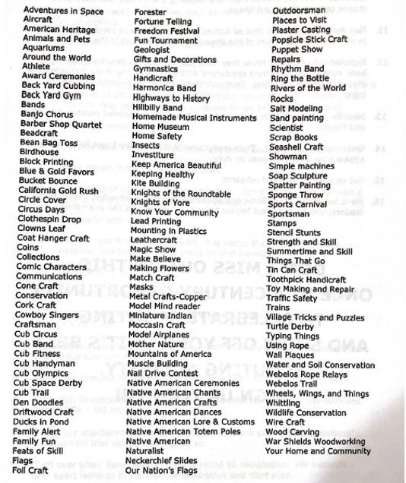
* This is not an all-inclusive list. Discuss all show ideas with Scout Show Coordinator.
Scout Show Ideas for Scouts BSA, Venturing, and Sea Scouts
These ideas are from a 2010 program and could be a little out dated.
They are provided to get you thinking.
Please contact/work with the Scout Shows Coordinator, Nancy Pendleton, for show ideas and show registration to avoid duplication.
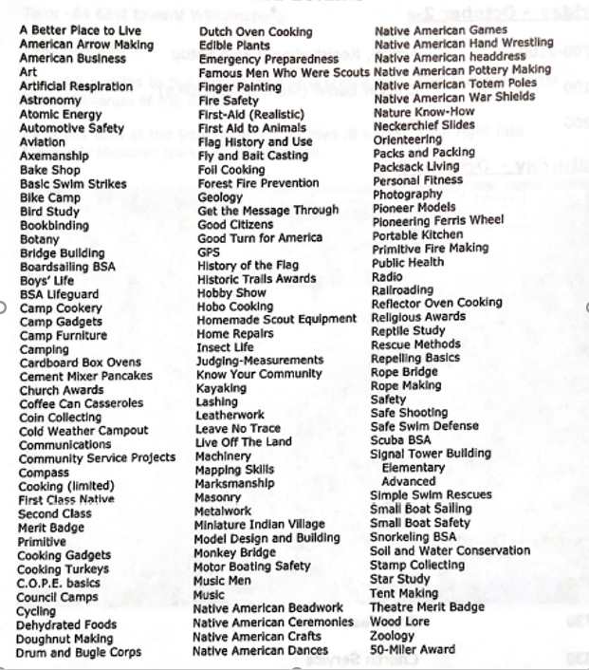
* This is not an all-inclusive list. Discuss all show ideas with Scout Show Coordinator.

