COLONIAL VIRGINIA COUNCIL
30TH ANNIIVERSARY T-SHIRTS
ORDER DUE BY SATURDAY OCTOBER 8TH
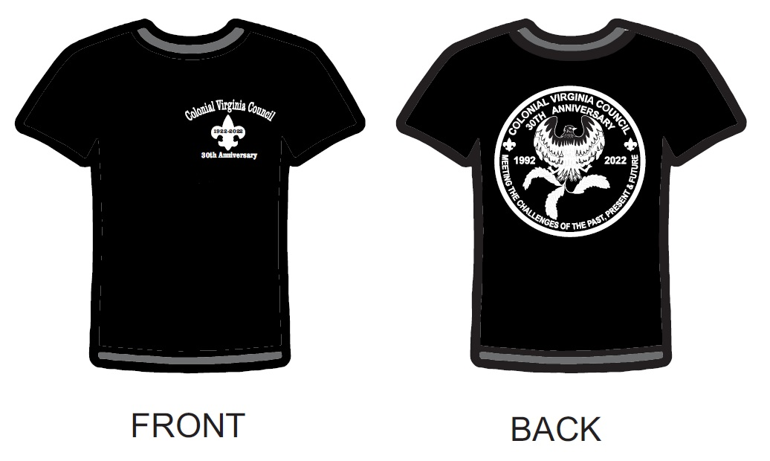

Shirt Size | Youth Small | Youth Medium | Youth Large | Adult Small | Adult Medium | Adult Large | Adult XL | Adult XXL | Adult XXXL
Quantity

Total Quantity: ________ x $17 = $__________

Purchasers will be informed when your items are available for pick up.
Would you like your items shipped to you when they are ready? Y / N
*Shipping charges will be calculated and will be due prior to shipping*
Orders can be emailed to sam.jennings@scouting.org

NAME: _________________________________________
ADDRESS: ________________________________________________________________
CITY: _____________________________ STATE: ______ ZIP: __________
EMAIL: _________________________________________ PHONE: _____________
PAYMENT METHOD
CASH/CHECK

CREDIT CARD: Name on Card: __________________________________
Card Number: ___________________________________
Exp Date: _____/_____ CVV: ________
PC = 718

