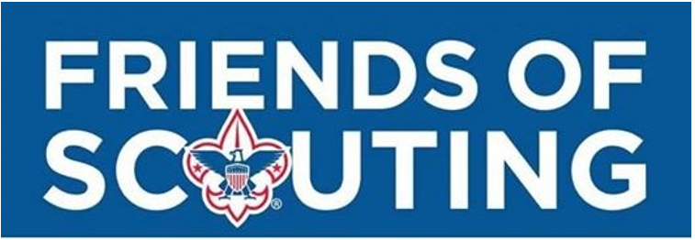

**COLONIAL VIRGINIA COUNCIL**



**BSA SERVICES**

-Stocked Scout Store

-Online Services (Online Recharter, Advancement, ScoutBook,

Be a Scout, Online Registration, My.Scouting, Online Training,

Doubleknot)

-Record Management (Membership, Scout Records, Awards,

Training)

-Eagle Kits of no charge to units/families

-Lowest costing Day Camps in the Area

-Printing and Postage

**FIELD STAFF**

- Membership Recruitment

- Training & Support - Community Relations

- Unit Support and Resource - Organizing New Units

**MEMBERSHIP RESOURCES**

-Recruitment Flyers & Posters

-Boys’ Life Mini-Mags

-Yard Signs

**INSURANCE**

-General Liability

-Accident

**But most are not aware of these very real costs that help make the Scouting program possible:**

**Tip of the Iceberg**

**Most are aware of these Costs of Scouting**

**FACILITY & SUPPLIES**

-Electricity

-Computers & IT

-Phone & Internet

-Paper & Printing

-Building Residency

-Program Equipment

**Uniforms, handbooks, badges, awards, event registration fees, weekend camping, summer camp, day camp, camping gear, Unit dues, National BSA registration fee, Boys’ Life**





**FRIENDS OF SCOUTING**

**2022**

**PLEDGE INFORMATION**

**I would like to contribute ______**

Make a one-time payment

Pay Quarterly

Pay monthly

**OR**

**I would like to contribute ______ each month thru Dec ‘22**

**SUPPORT A SCOUT FOR A YEAR - $300**

**I would like to support:**

1 Scout ($300) 2 Scouts ($600) ___ Scouts

(# x $300)

Make a one-time payment

Pay monthly

Monthly Payment Amounts based on $300 per Scout

(Payments begin month after pledge card is submitted)

|  |  |  |  |
| --- | --- | --- | --- |
| Nov/Dec ‘21 | $25.00 | June ‘22 | $50.00 |
| Jan ‘22 | $27.27 | July ‘22 | $60.00 |
| Feb ‘22 | $30.00 | Aug ‘22 | $75.00 |
| March ‘22 | $33.33 | Sept ‘22 | $100.00 |
| April ‘22 | $37.50 | Oct ‘22 | $150.00 |
| May ‘22 | $42.85 | Nov ‘22 | $300.00 |

**OR**

**ADDITIONAL SUPPORT OPPORTUNITIES**

**Please provide me more information about:**

Supporting the Council Endowment

Planned Giving Opportunities

Council Special Events

(Golf Tournament/Fundraising Banquets)

**CONTACT INFORMATION**

**Donor’s Signature: _____________________________________________________________ Date: ______________________**

**Donor’s Name: _________________________________________ Scout’s Name: ____________________________________**

**Address: _____________________________________________________________________________________________________**

**City: ____________________________________________________ State: _______ Zip: _______________**

**Email: ____________________________________________________________ Phone: ________-________-_________________**

**Unit: ___________________ District: _____________________**

**PAYMENT OPTIONS**

**Bill Me I will set up Automatic Bill Payment with my financial institution payable to Colonial Virginia**

**Council; PO Box 12144 Newport News, VA 23612**

**Cash/Check Credit Card PAY ONLINE**

**Credit Card #: _______________________________________________________**

**Expiration Date: ____________ CVV#: _________**

**Name on Card: _______________________________________________________**



**THANK YOU FOR YOUR SUPPORT!!!**