The Colonial Virginia Council, Boy Scouts of America
Invites you to join them
for the
Council Annual Recognition Banquet

Recognizing the service of outstanding volunteers,
Silver Beaver recipients, the 2018 Class of Eagle Scouts, Quartermasters, and Summit Award recipients and many other outstanding honorees.
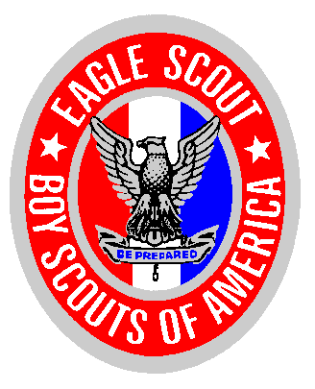
Saturday, March 23rd, 2019—6:00 pm
(Check-in begins at 5:00 pm)
Hilton Garden Inn
5921 Harbour View Blvd, Suffolk, VA

Dress: Field Uniform or Business Attire Open Seating

Please detach & return this form along with payment to:
Colonial Virginia Council, PO Box 12144, Newport News, VA 23612
Reservations must be received no later than March 16th, 2019

Name of 2018 Eagle Scout/Quartermaster/Summit Award:
_______________________________________ Unit Type & Number:_________
# of Guests __________ x $35.00 = $___________
Eagle Scouts (free): __________ x $0
Total people attending: __________
I would like to sponsor ______ Eagle Scouts x $35.00 = $___________

Total amount included= $___________
Please mark your method of payment:

Cash Check Visa MasterCard Discover AmEx

Make all checks payable to Colonial Virginia Council or CVC.

For Credit Card Payments:

Name as it appears on card: ______________________________________________________________

CC # _______________________________________________________________________

Exp. Date: ___________________ 3-Digit Code: ____________________

Signature for Authorization: ____________________________________________________________________

For more information contact Council Service Center 757-595-3356 or email Sam.Jennings@scouting.org

