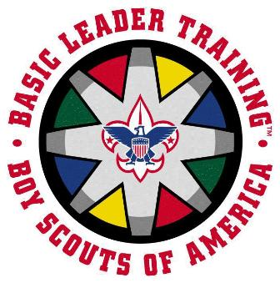
TRAINER DEVELOPMENT
The Trainer's EDGE™

Attend Training
- Bring a Buddy
Explain: The trainer explains how something is done.
Demonstrate: The trainer demonstrates while explaining again.
Guide: The learner tries the skill while the trainer guides him through it.
Enable: The learner works on his own under the eye of the trainer.

When: November 8, 2014. 7:45 a.m. ‘til 5:00 p.m.

Where: Peninsula Community Chapel, 4209 Big Bethel Rd, Yorktown, VA
Cost: $15.00 Includes registration, handouts, lunch, and a day full of incredible fun-filled training!

Leadership training is a major part of Scouting, and this training session will teach trainers how to conduct an effective training session. The course will include an opportunity to prepare and conduct presentations and demonstrate skills.

Who should come?
• Youth trainers for NYLT, Venturing, Roundtable, Order of the Arrow, and Summer Camp
• District trainers in Cub Scouting, Boy Scouting, and Venturing
WEAR YOUR UNIFORM
• Council trainers in Wood Badge, NYLT, Youth Protection, and all the other trainings
• Commissioners-Unit, District, Assistant District, and Roundtable
• Any Scout Leader who wants to learn to communicate ideas better

Learn
• Why & how we train leaders; & how to do it effectively
• How adults learn
• What's important about communication
• Characteristics of a good trainer
• How to plan training
• What kind of arrangements do you need to make
• What kind of technology works best in any given situation
• The latest training methods
• How to get that EDGE into whatever you do!
Pre-course Prepare a 10 to 12 minute presentation on any BSA topic to share with the course participants.
Preparation: Your presentation should allow you to demonstrate the skills of a trainer.
The course encompasses feedback on your presentations as part of its practical exercises.

For more information: Karen Sutley karensutley@cox.net or (757) 209-7989
Registrations taken at the Scout Shop during normal business hours. 11721 Jefferson Ave., NN
CVC Trainer Development – Trainer’s E.D.G.E. –November 8, 2014

REGISTERED Name: _____________________________ Dietary Restrictions: ______________________

(Prefer)
BSA ID# _____________________ OR Address: ________________ ___________________ _______

Primary Phone: _______________________ E-mail: __________________________________________

Council: _________ District: ________ Unit Type & No: __________ REGISTERED Position: ___________
Early Bird FEE: $15 – thru Oct 30th (Lunch included) Amount Paid: $ __________
Regular FEE: $20 – accepted at Scout Shop Oct 31 through Nov 4 Event Code: =725
WALK IN FEE: $25 – discouraged but not prohibited; handouts not guaranteed and makes meal planning difficult.

