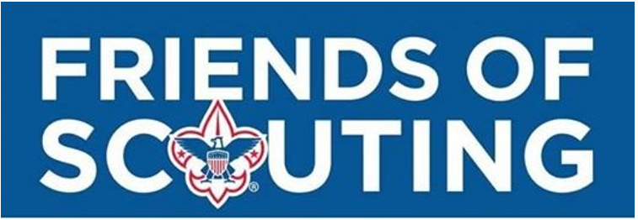
COLONIAL VIRGINIA COUNCIL
BSA SERVICES
-Stocked Scout Store
-Online Services (Online Recharter, Advancement, ScoutBook,
Be a Scout, Online Registration, My.Scouting, Online Training,
Doubleknot)
-Record Management (Membership, Scout Records, Awards,
Training)
-Eagle Kits of no charge to units/families
-Lowest costing Day Camps in the Area
-Printing and Postage

FIELD STAFF
- Membership Recruitment
- Training & Support - Community Relations
- Unit Support and Resource - Organizing New Units

MEMBERSHIP RESOURCES
-Recruitment Flyers & Posters
-Boys’ Life Mini-Mags
-Yard Signs
INSURANCE
-General Liability
-Accident
But most are not aware of these very real costs that help make the Scouting program possible:
Tip of the Iceburg

Most are aware of these Costs of Scouting
FACILITY & SUPPLIES
-Electricity
-Computers & IT
-Phone & Internet
-Paper & Printing
-Building Residency
-Program Equipment
Uniforms, handbooks, badges, awards, event registration fees, weekend camping, summer camp, day camp, camping gear, Unit dues, National BSA registration fee, Boys’ Life

Colonial Virginia Council
Boy Scouts of America
2021 Friends of Scouting Campaign Pledge
I pledge to Support a Scout for a Year with my $200 contribution
to the 2021 Friends of Scouting Campaign:

(Monthly Payment Option - Please Check One)
___ $16.66 per month for pledges made in December 2020, paid over twelve months, Jan - Dec 2021
___ $18.18 per month for pledges made in January 2021, paid over eleven months, Feb – Dec 2021

___ I would like to contribute $______________ per month for __________ months (all pledges must be paid in
(number of months) full by December 31, 2021)
Payment / Billing Information: (Please Check One)

___ I will set up an Automatic Bill Payment with my financial institution and have a check sent monthly made
payable to Colonial Virginia Council and sent to P.O. Box 12144 Newport News, VA 23612

___ I would like to receive a billing statement in the mail monthly

___ I have provided my credit card information in the box below and would like my card charged monthly

OR
Pledge Information: I would like to contribute $________________for ______ year(s).

Payment Information: (Please choose 1 or 2 below)

1) I prefer to pay in full now: (Check One) ___Cash Enclosed ___Credit Card ___Check Enclosed
Payable to: Colonial Virginia Council

2) Please (check one): Bill Me or Charge my credit card:
___ One Payment on ________________ (date before Dec 31, 2021)
___ Two Payments on _______ & _______ (dates before Dec 31, 2021)
___ Four Payments in equal installments through December 31, 2021

Credit Card #____________________________________
Expiration Date: _____________ CVV#: ____________

(Circle One) Visa MasterCard AmEx

Please complete the information below, including signature

Donor Signature: ______________________________________ Date: __________________
Contact Information: (Please Print Clearly)
Donor’s Name: ______________________________ Scout’s Name: _____________________

Address: ______________________________________________________________________

City: ___________________________________ State: _______ Zip: ________________

Work Phone: __________________________ Home / Cell Phone: ______________________

Email Address: _________________________________________________________________

BSA Structure/District: ______________________ Giving Category/Unit: ____________________

